OPERATING SYSTEMS AND SYSTEMS PROGRAMMING
Skill 13,14
2520030159-hema sri
13.To Parse Input Redirection, Open Files, Redirect stdin, Handle Missing Files, Restore Streams, Test File Inputs.
To Parse Output Redirection, Create Output Files, Redirect stdout, Handle Permissions, Verify Output Data, Test Redirection.
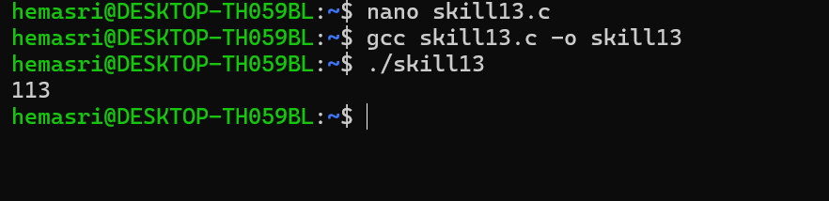
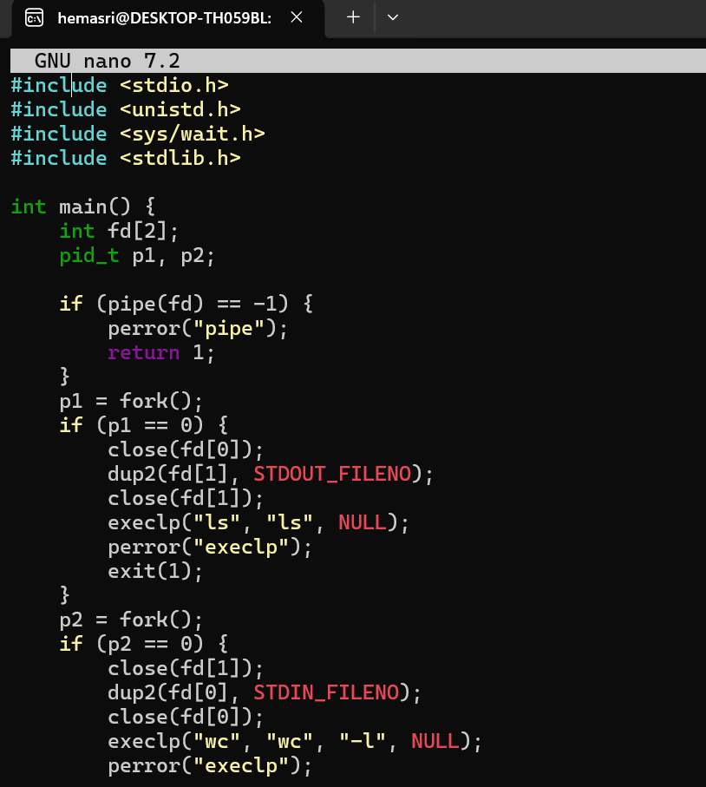

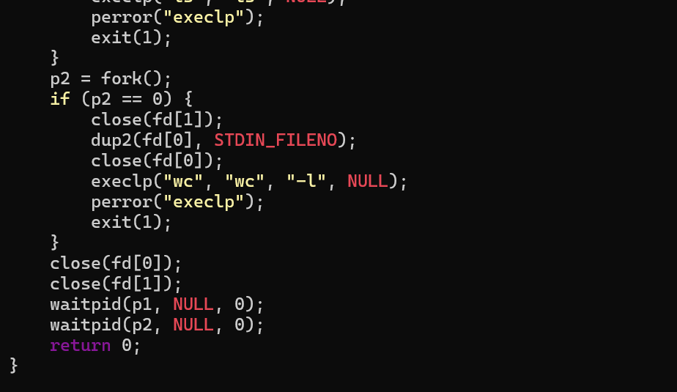

14. To Parse Append Operator, Open Files in Append Mode, Redirect Streams, Preserve Existing Data, Validate Appends, Test Scenarios.
To Parse stderr Redirection, Redirect Error Streams, Capture Error Output, Verify File Contents, Handle Failures, Test Error Cases.
